

# National University of Computer & Emerging Sciences (FAST-NU)

SOFTWARE DESIGN AND ANALYSIS PROJECT REPORT

COURSE INSTRUCTOR: SIR UBAID AFTAB CHAWLA

MADE BY

**K18-1148 Uzair Ali Section E**

# INTRODUCTION

In todays world games are becoming really popular especially multiplayer FPS ( FIRST PERSON SHOOTER ) , Battle Royal games like PUBG (PLAYER UNKNOWN BATTLE GROUNDS), CODM (CALL OF DUTY MOBILE), FORTNITE, HYPERSCAPE etc. My project demonstrates how these Multiplayer games work and to show this I made a game that works on the same principles that these high end games (mentioned above) works on.

# MOTIVATION

I play Battle Royale games a lot and after researching I found out that these games generate revenue greater than HOLLYWOOD even though these games are free to play, in addition these games allow the player to earn capital by playing in tournaments, YOUTUBE streaming, TWITCH streaming etc. So, this motivated me and INSHAALLAH ill bring a similar Battle Royale game to PAKISTAN someday.

# SIGNIFICANCE

The importance of this project is that it will help other beginner game developers to get the idea of how a multiplayer FPS game works.

# DESCRIPTION

## BACKGROUND:

Even though there are uncountable FPS multiplayer games available I chose this idea because there is no FPS Battle Royal game made by our country PAKISTAN. Even INDIA has developed its own Battle Royal game FAU-G which is kind of shame full for us.

## SIMILAR WORKS:

As I said earlier there are various game giants like TENCENT STUDIOS, UBISOFT etc. who are creating these kind of games.

# FEATURES

There are THREE systems working together to make this game possible and they are:

1. PHOTON SERVER: Provides 20 free CCUs (concurrent users) meaning that 20 players can play multiplayer at once. This also provide room creation for free. This is the backbone of this project because without PHOTON multiplayer gaming in not possible
2. PHP MAMP SERVER: This allows this game to save player XP into the database and allows the player to start with the same rank where he left of.
3. UNITY ENGINE: without UNITY engine this whole game was not possible. As the name tells this is the game engine which creates the whole 3D world, Characters etc. and makes game playable through scripts attached to the game objects
4. PLAYER: This is the Player which interacts with the other player via game world connected through internet.

# STAKE HOLDERS

* + SYSTEM USER

|  |  |  |
| --- | --- | --- |
| USERS | USAGE OF SYSTEM | BENEFIT RECEIVED FROM SYSTEM |
| Player | * Enters name * Enters Room name * Kills the other player * Restarts the game * Quits the game | * Personal satisfaction * Skills development |

* + SYSTEM DESIGNER: UZAIR ALI
  + SYSTEM ANALYST: UZAIR ALI
  + SYSTEM DEVELOPER: UZAIR ALI
  + EXTERNAL SERVICE PROVIDER: PHOTON, MAMP, Teacher

# FUNCTIONAL REQUIREMENT

* + UNITY ENGINE
    - System should be connected to power souce
    - System must be connected to the internet
    - System must take user name and room name
    - System must connect to the MAMP server and create user or fetch user if existed
    - System must connect to PHOTON server
    - System must create room with the room name provided
    - System must load every game asset
    - System should be able to switch between the different scenes upon requirement
  + MAMP DB SERVER
    - Server should be connected to power source
    - Server should have a database “PlayerStats”
    - Server must be running
    - Server must be connected to the internet
  + PLAYER
* Player must be present
* Player should have a name

# NON-FUNCTIONAL REQUIREMENTS

* USER REQUIREMENTS
* Game FPS (frames per second) should be above 60
* Game should take less RAM
* Game should take less HDD storage
* EXTERNAL REQUIREMENTS
* Game should be licensed
* Players under 14 cannot play
* Game should not show any violence
* Game should be rated E (everyone)

# DOMAIN BINARY REQUIREMENTS

* CPU: Intel Core 2 Duo @ 2.66 GHz or AMD equivalent
* CPU SPEED: 2.5 GHz
* RAM: 2 GB (XP) / 3 GB (Windows 7 / Vista)
* OS: Microsoft Windows 7/Vista/XP
* VIDEO CARD: NVIDIA GeForce GT220 (512MB) / ATI Radeon HD 2600 XT (512MB)
* PIXEL SHADER: 3.0
* VERTEX SHADER: 3.0
* SOUND CARD: Yes
* FREE DISK SPACE: 8 GB
* DEDICATED VIDEO RAM: 512 MB

# DIAGRAMS

# CLASS

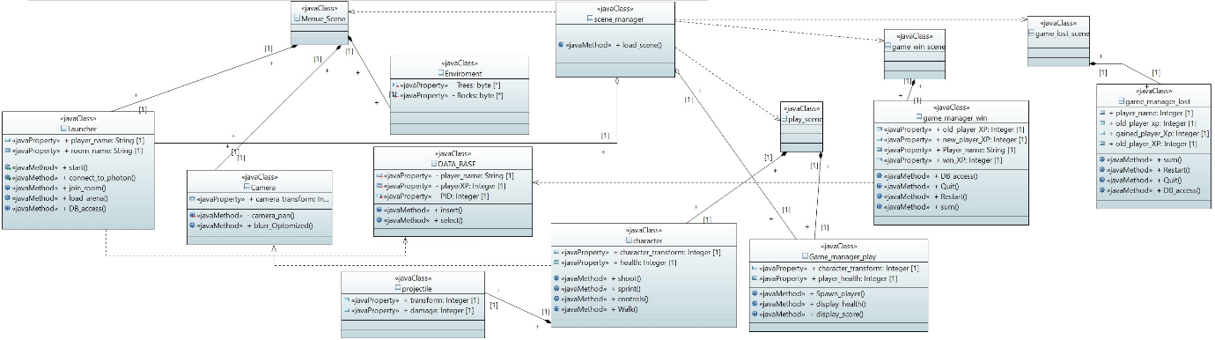

# ACTIVITY

SCENARIO 1 (WIN)

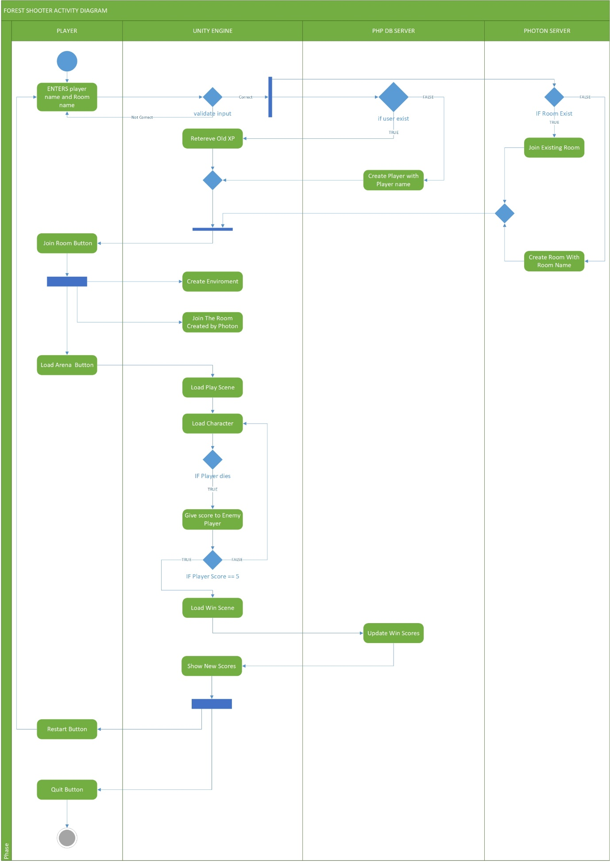

SCENARIO 2 (LOST)

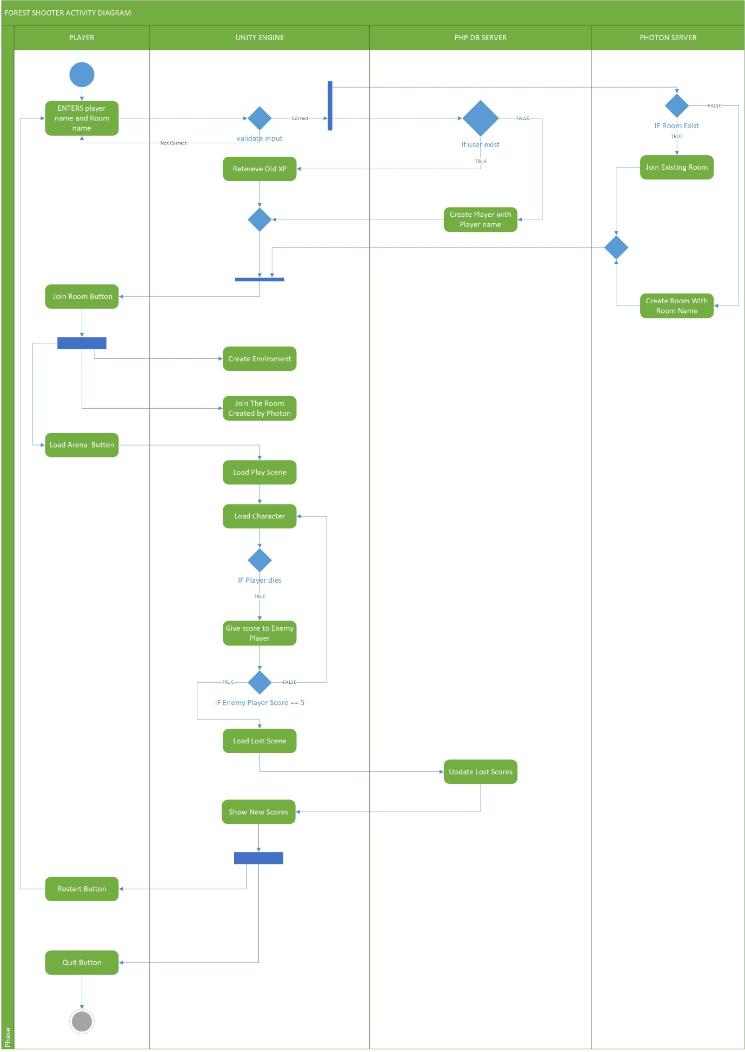

# COLLABORATION

SCENARIO 1 (WIN)

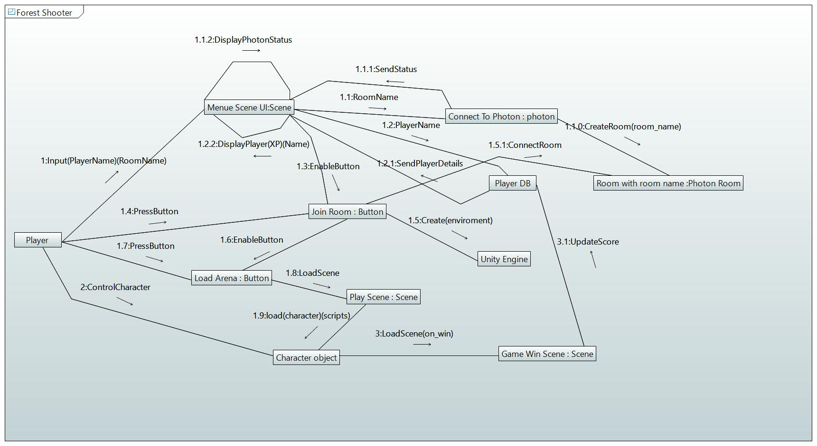

SCENARIO 2 (LOST)

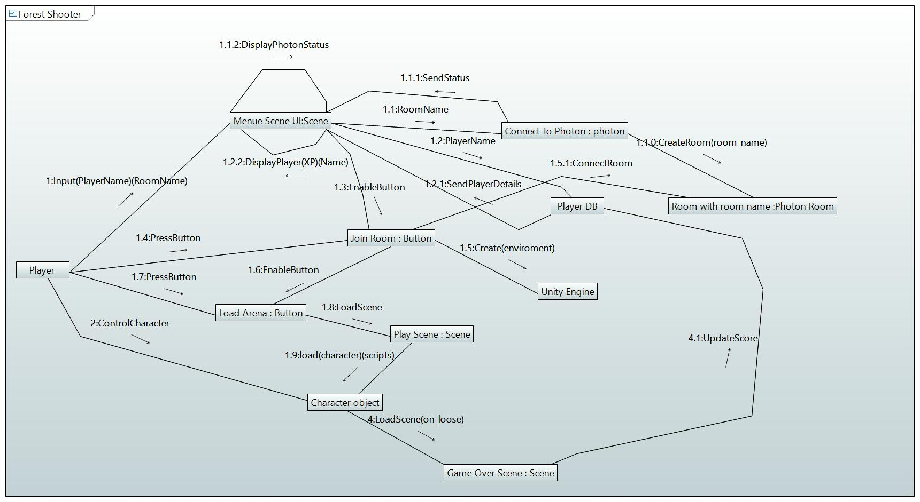

# DEPLOYMENT

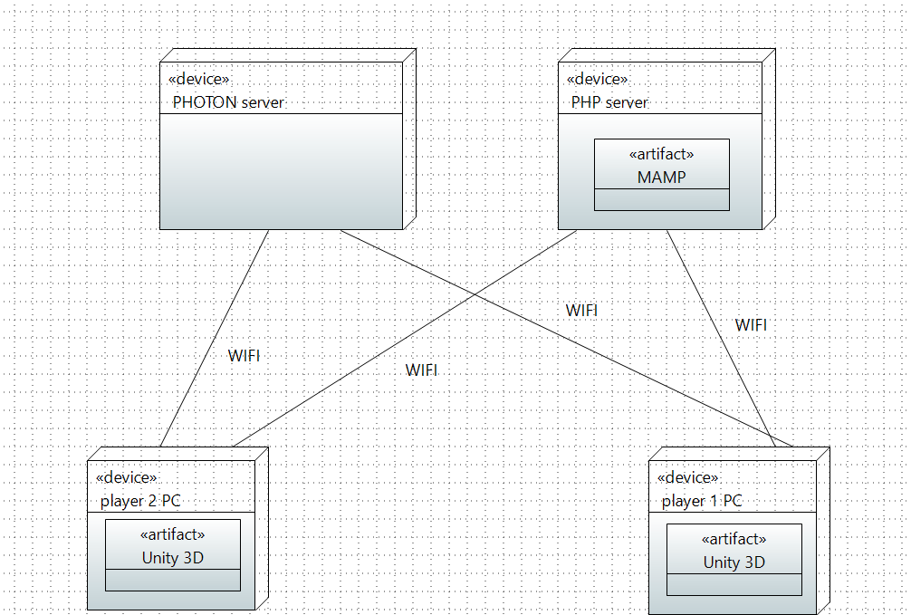

# ECB (Entity Control Boundary)

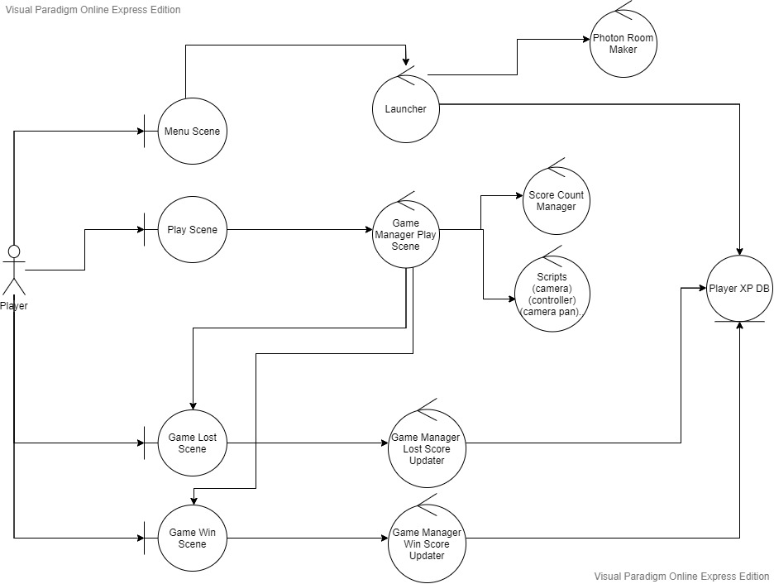

# SEQUENCE

SCENARIO 1 (WIN)

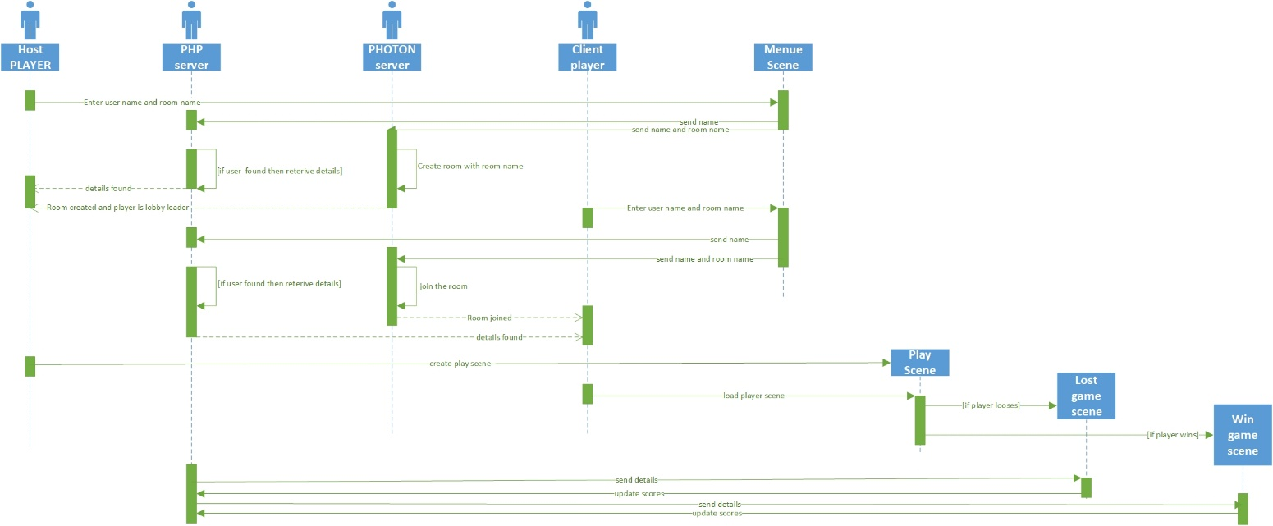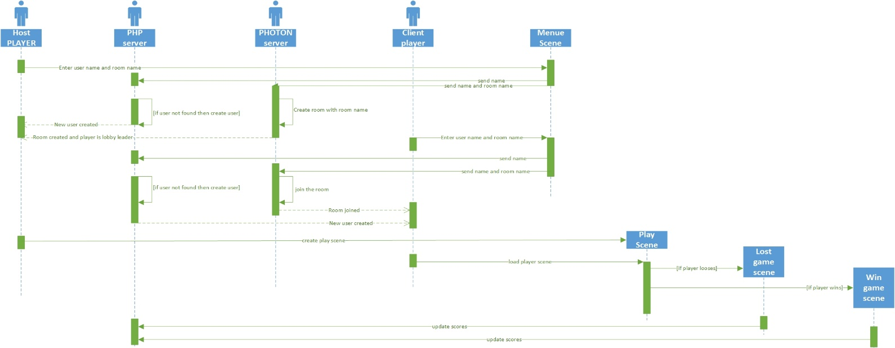SCENARIO 2 (LOST)

# STATE

SCENARIO 1 (ENGINE OBJECT)

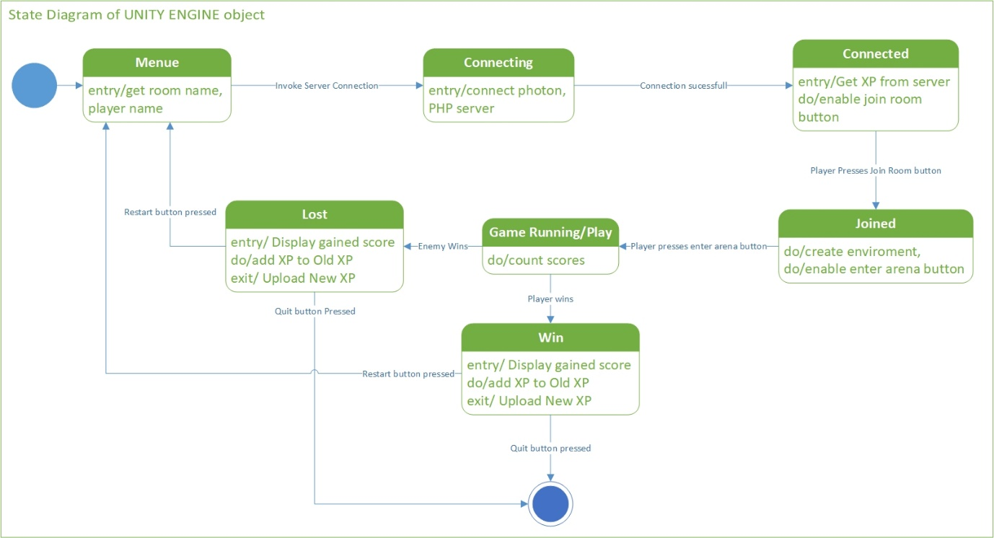

SCENARIO 2 (CHARACTER OBJECT)

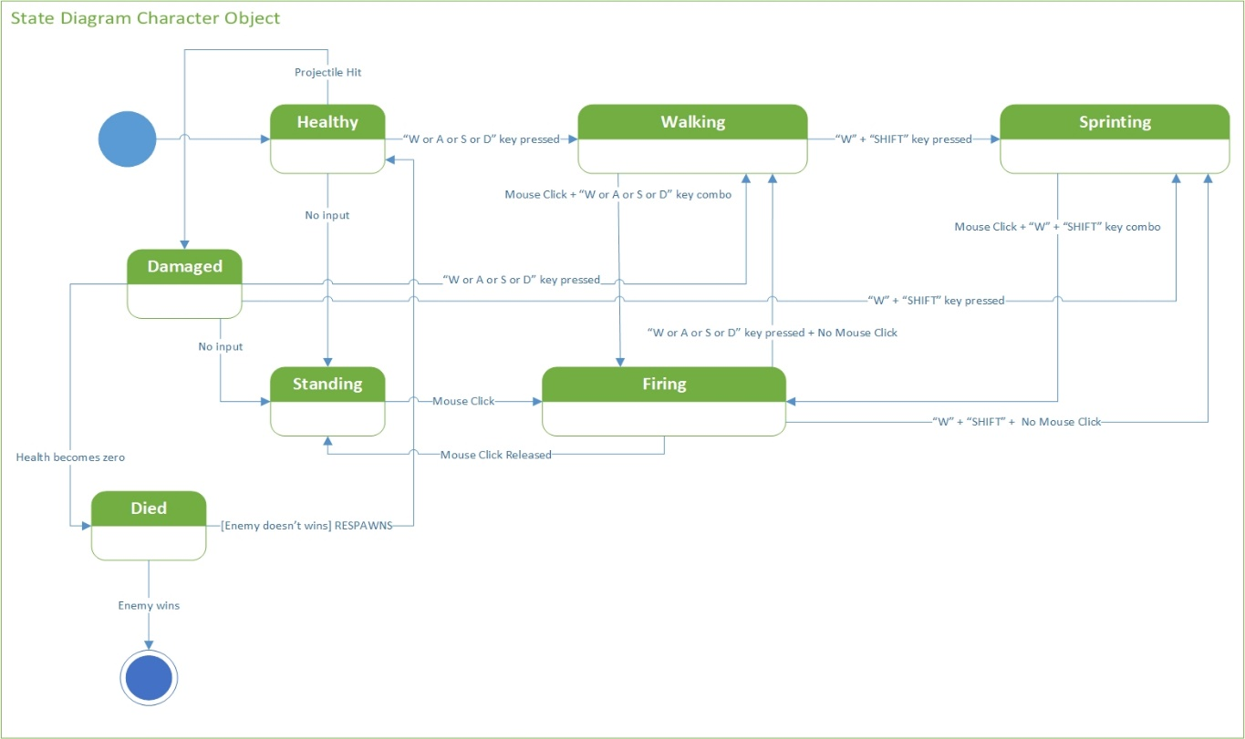

# UML USE CASE

